Manipulative | Name | How it can be Used
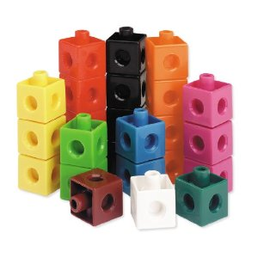 | Snap Cubes | These are ideal for learning and modeling number concepts, and solving three-dimensional spatial reasoning tasks.  - patterning - grouping - sorting - counting - numbers - addition - subtraction - multiplication - division - measurement
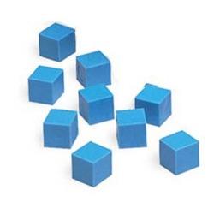 | Base Ten Unit Cube | You can place them together to form a Rod, 100 Units form a Flat, and 1,000 Units make a Cube.  These are great to show ‘trading out’ with the base tens to show the rationale behind regrouping.
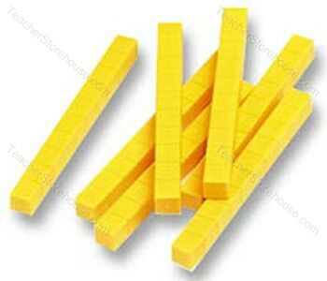 | Base Ten Rod | Ten Rods connect to form a Flat, and 100 Rods can link to form a Cube!  These are great to show ‘trading out’ with the hundreds flat to show the rationale behind regrouping.
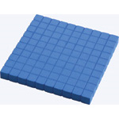 | Hundred Flat | Connect 10 Flats to form the Cube.  These are great to show ‘trading out’ with the thousands cube to show the rationale behind regrouping.
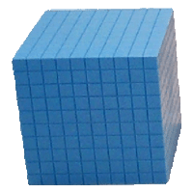 | Thousand Cube | Great to show larger numbers and introduce into the 3D shape of a cube (it’s not just four, but 10 hundreds).
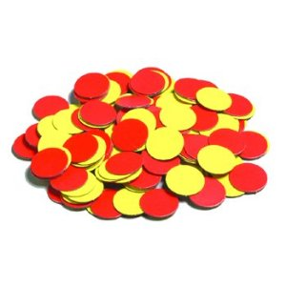 | 2 Color Counters | These are ideal for learning and modeling number concepts, and solving three-dimensional spatial reasoning tasks.  They are also awesome with showing positive and negative integers and the rationale behind why ‘two negatives=a positive.”  - patterning - grouping - sorting - counting - numbers - addition - subtraction - multiplication - division - measurement
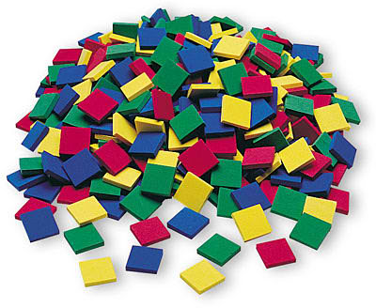 | Color Tiles | - Perfect for modeling important math concepts to develop basic arithmetic skills, logical thinking, and algebraic and geometric understanding  - Useful for activities in patterning, counting, sorting, measuring, fractions, estimation, and place value
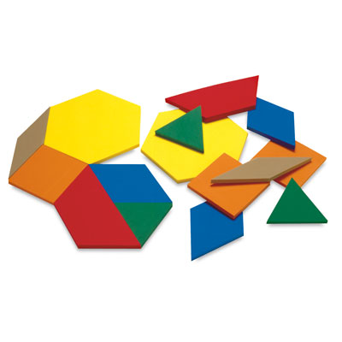 | Pattern Blocks | These are great to use with composing and decomposing shapes. It is also great for showing patterns of color, size and shape. These have more irregular pieces than the ‘plane shapes.’ Students could also use these for measurement and estimation.  These are also great to use with fractions as students always see fraction in relation to a rectangle/square or a circle-so these help them to know fractions can be cut with other figures as well.
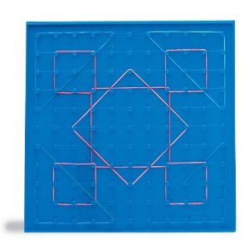 | Geoboard | These are great to explore area, perimeter, fractions, congruence, and symmetry. If you have itn the reverse, an 11 x 11-pin coordinate grid can be used for plotting, map skills practice, and graphing.
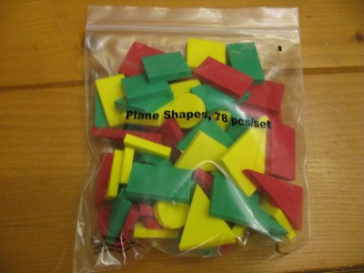 | Plane Shapes | These are great to use with fractions as students always see fraction in relation to a rectangle/square or a circle-so these help them to know fractions can be cut with other figures as well.  These are also great to use with composing and decomposing shapes. It is also great for showing patterns of color, size and shape. These contain your basic regular 2D plane shapes. These are great to show with nets in the upper grade level and again for building patterns in the primary grades. Students could also use these for measurement and estimation.
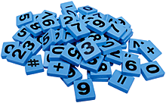 | Number and Symbol Tiles | These are great for setting up number sentences and variable expressions.
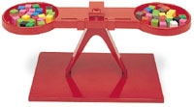 | Pan Balance | This is a great tool to use in estimation, measurement and algebraic thinking. It’s a great segue into balancing equations.
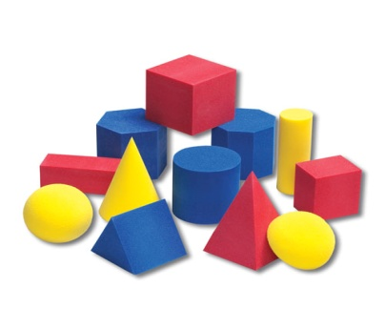 | Geo Solids | These are great to have students master the dimensions of 3D shapes and attributes of each shape (face, vertices, edge,etc.).
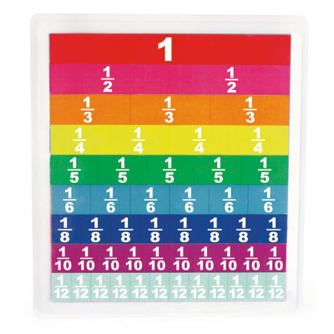 | Fraction Tiles | These are also great to use with fractions, percents, and eventually decimals and the equivalence between them. These show students that more than one type of fraction can make a whole. This sets them up nice when they start to add fractions with unlike denominators in 5th grade.
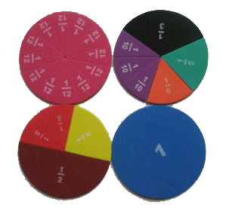 | Fraction Circles | These are a great way to start introducing fractions; relevant to real world (pizza, pie, etc.) and percents. Again, these show students that more than one type of fraction can make a whole. This sets them up nice when they start to add fractions with unlike denominators in 5th grade.

Please make sure that your manipulatives are NOT in the big white box still and are easily accessible to students.

