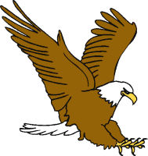  Eagle Eye | Look at the Pictures  - Look at the picture for clues
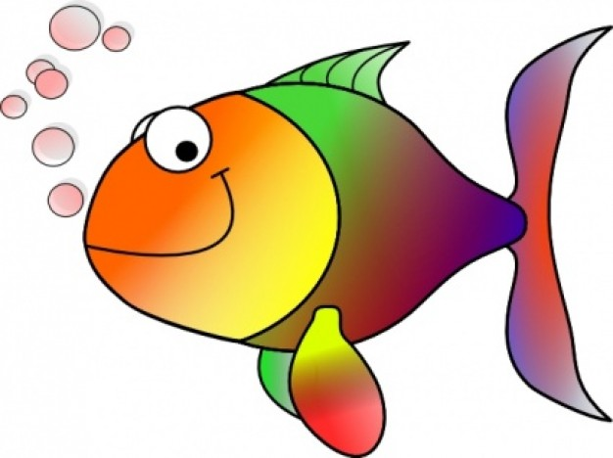  Lips the Fish | Get your Lips Ready  - Say the first few sounds.  - Read to the end of the sentence and say it again.
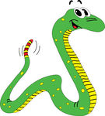  Stretchy Snake | Stretch It Out  - Stretch the word out slowly.  - Put the sounds together.
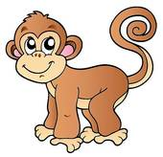  Chunky Monkey | Chunk the Word  - Look for a chunk (-at, -an).  - Look for a word part (-th, -ed).

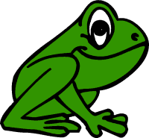  Skippy Frog | Skip It, Hop Back  - Skip the word.  - Read to the end of the sentence.  - Hop back and read it again.
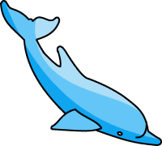  Flip the Dolphin | Flip the Vowel  - Try the short vowel sound.  - Try the long vowel sound.
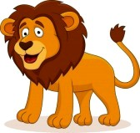  Tryin’ Lion | Try It Again  - Try to reread the sentence.  - Try a word that makes sense.  - Try to switch b/d.
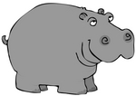  Helpful Hippo | Ask for Help  - Ask for help after you have tried all of the other strategies.
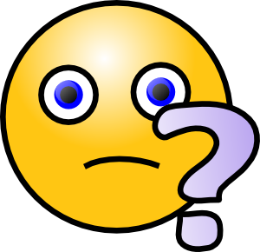 | Stuck on a tricky word?

