ESOL Resource Book

Policies and Procedures
- Photo w/ Thought Bubbles
- Pictorial Behavior Instructions
- http://www.brown.edu/academics/education-alliance/teaching-diverse-learners/policy
- Native Language Button
- Whole Body Listening
- Bi-lingual classroom signs

Assessment
- Phonics Survey
- Independent Reading Conference
- Yodio(http://ellclassroom.com/category/english-proficiency/lep-limited-english-proficient/)
- CELLA
- Assessment Accommodation web page, Wisconsin Department of public instruction webpage
http://oea.dpi.wi.gov/oea_accommtrx/#Aell

Parent/Community Involvement

- Hillsborough County Public Schools Title 1 Parental Involvement plan (English/Spanish)
- nepc.colorado.edu/files/pb-options-7-ellparents.pdf‎
  - Cached
  - Similar

Content Area/Grade Level
- http://www.english-4kids.com/grade3.ht
- Academic Vocabulary lesson
- ESOL Strategies Checklist
- Cloze Activity
- Realia
- Alphaboxes
- Syntax Surgery
Program Models
- SIOP Model

Policies and Procedures

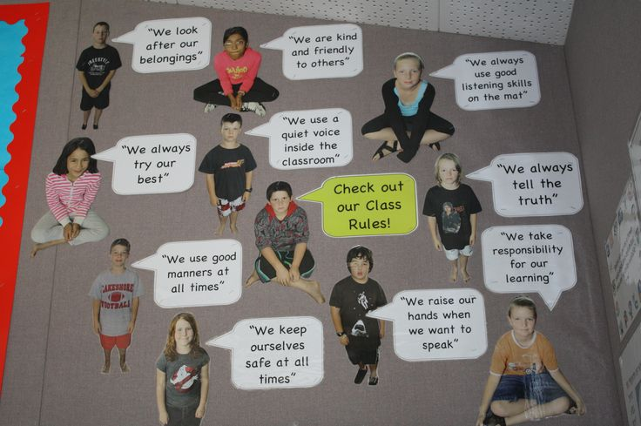
Pictures of students with a thought bubble explaining class norms. These can be good for ELL’s that are more proficient in the English language because they can probably read most of the text, but they can also interpret the meaning by the student’s expression in the pictures.
Classmate Photos with thought bubbles

These help ELL’s know what to do and when to do it by providing a clear visual. These are beneficial to our English speaking students as well and can be easily implemented.
Pictorial Behavior instructions
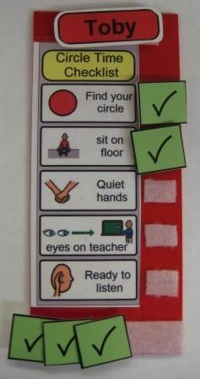

http://www.brown.edu/academics/education-alliance/teaching-diverse-learners/policy

This site provides information on school policies and procedures regarding ELL’s. It also provides descriptions and information about past court cases and laws pertaining to the rights of ELL’s. This site has useful information regarding legalities of accommodation for ELL students.

Brown University Website

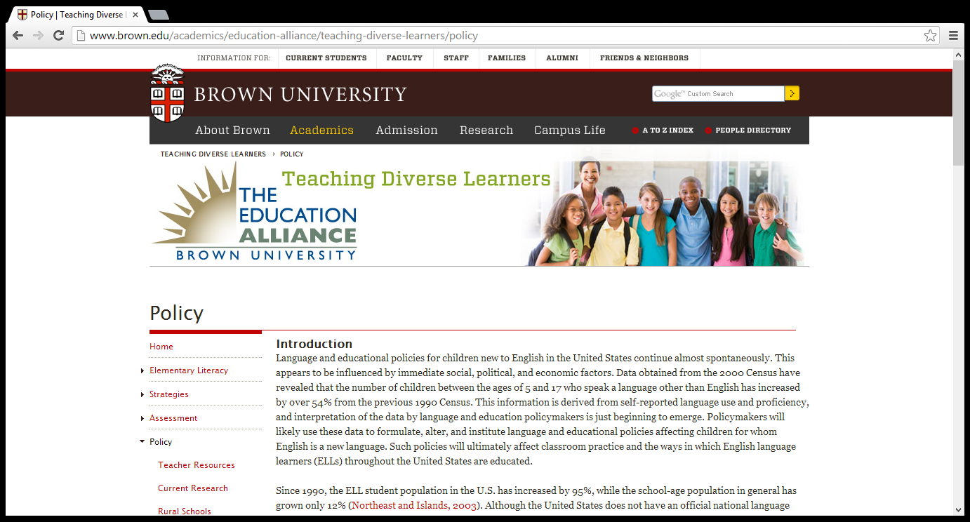

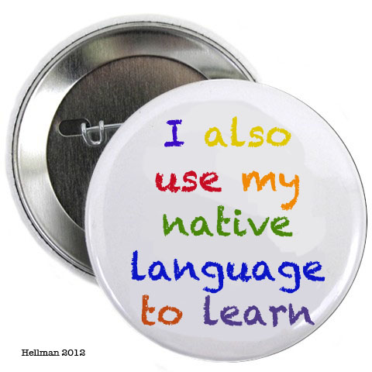
This badge can help my English Language Learners feel comfortable about using their native language in the classroom. This is also a way for us to show them that their native language is important and appreciated
Native Language Button

This poster can help show by pictures how to listen and participate appropriately during class.
Whole Body Listening

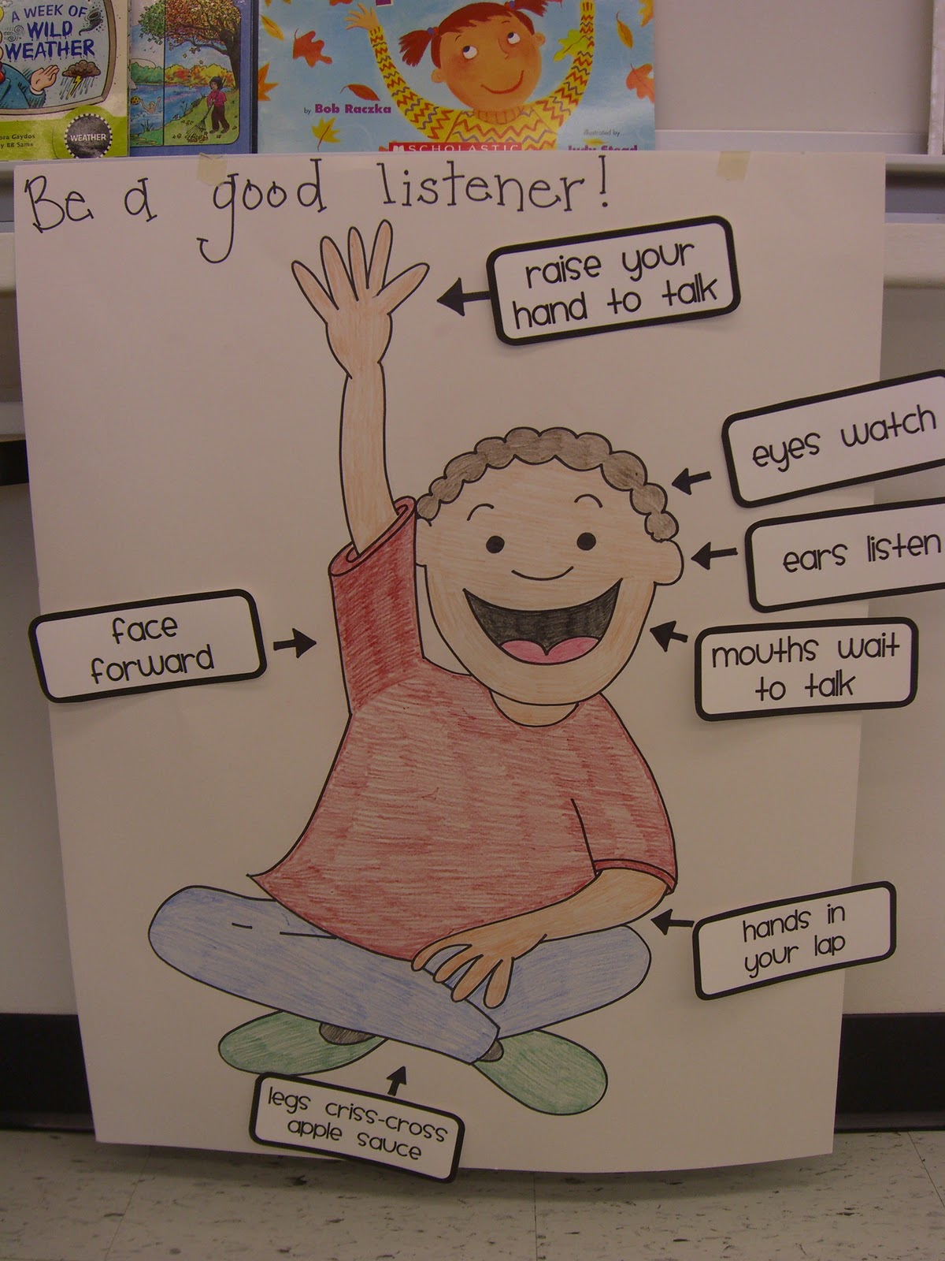

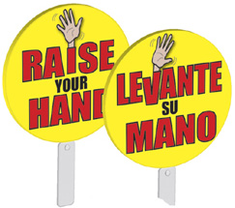
Bi-lingual classroom signs allow students to follow procedures with the rest of the class and have access to these procedures in their native language.
Bi-lingual classroom sign

Assessment

Phonics Survey
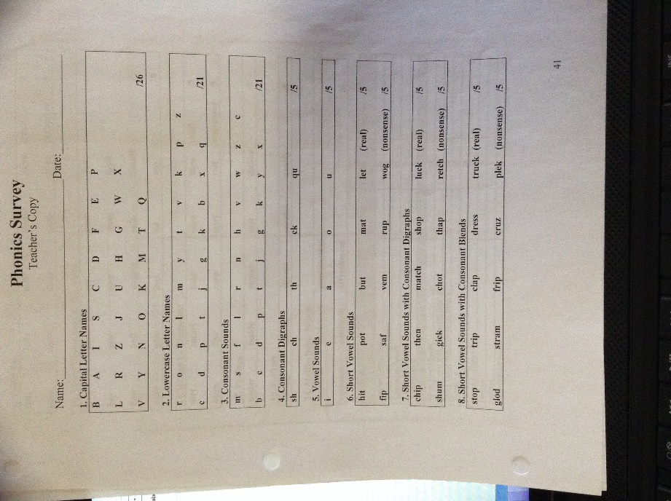
These help to diagnose comprehension and performance in speaking the English language and help to diagnose which areas need the most attention.
Phonics Survey
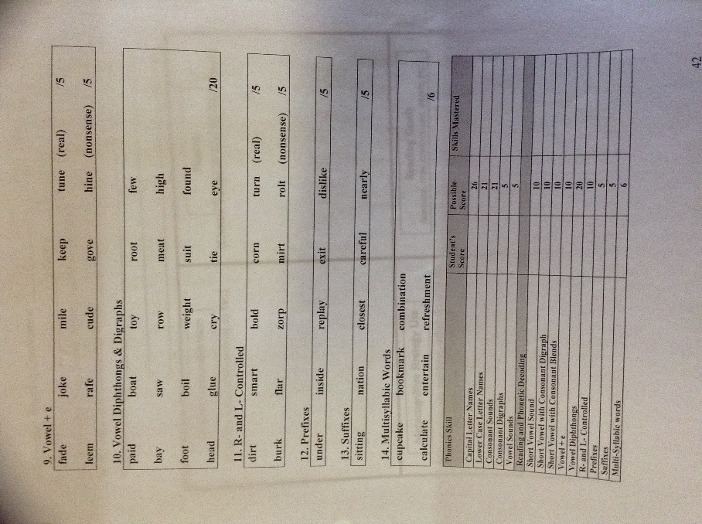
Independent Reading Conference
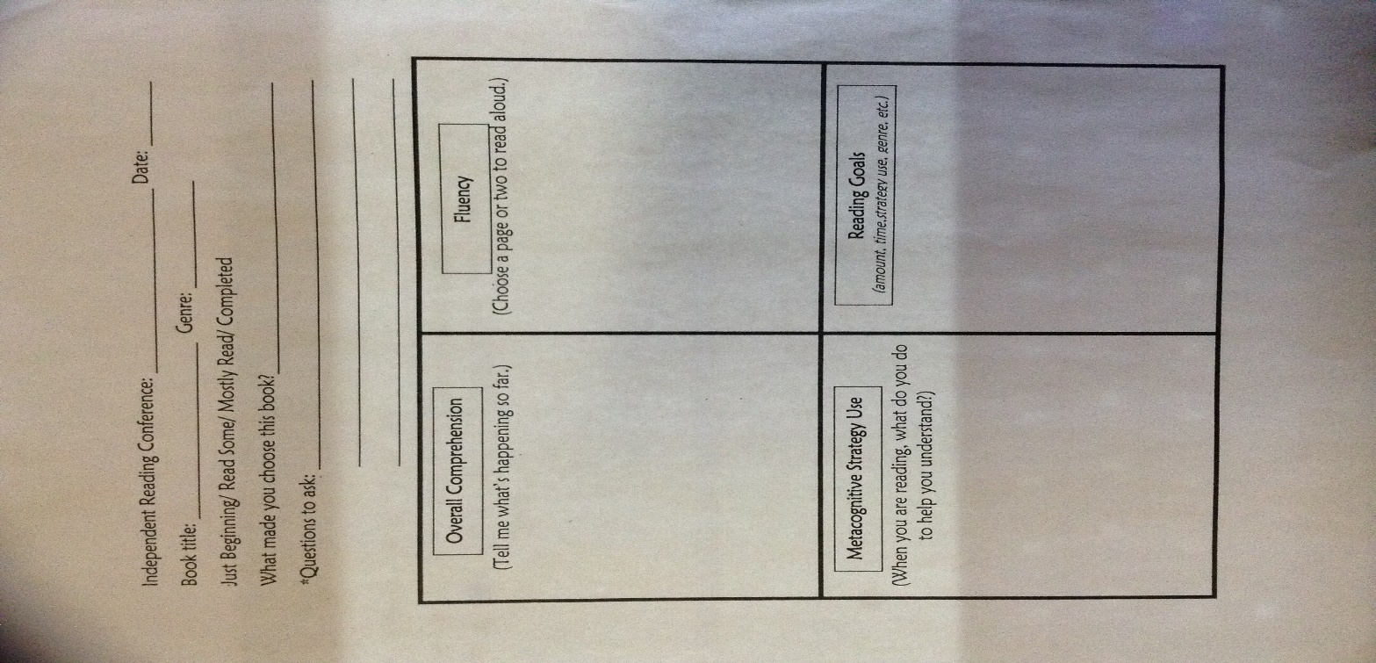
These help us to determine whether or not a student is choosing a just right book. It tells us whether they are able to comprehend the contents of the book well enough to re-tell it. From here we can determine whether they are reading appropriate materials during independent reading in order to better learn and understand the English language as it applies to children’s literature.
Independent Reading Conference

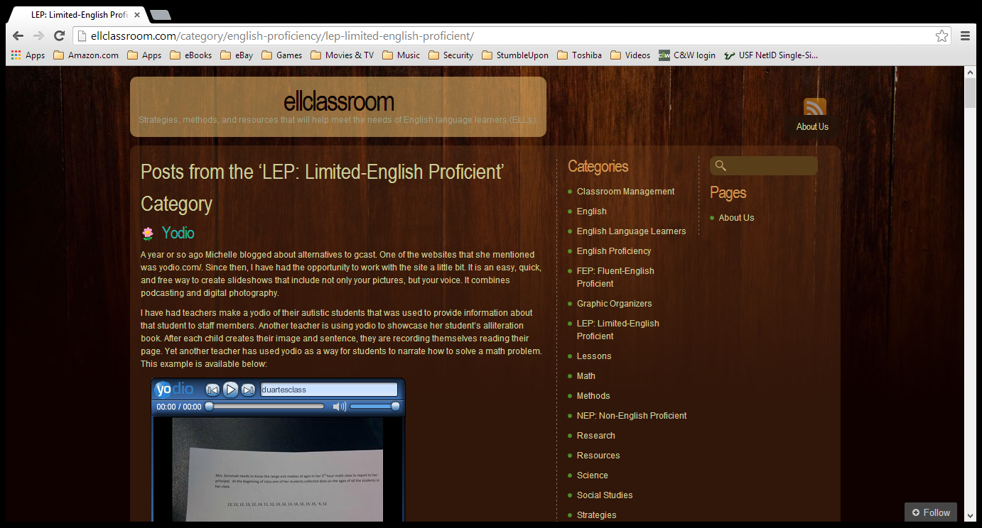
This can be used to track an ELL’s ability to read a text. This allows them to create a presentation of pictures and a voiceover. They can submit this to showcase ability or comprehension without being placed in the uncomfortable situation of having to read aloud in front of an entire class.
Yodio.com
CELLA
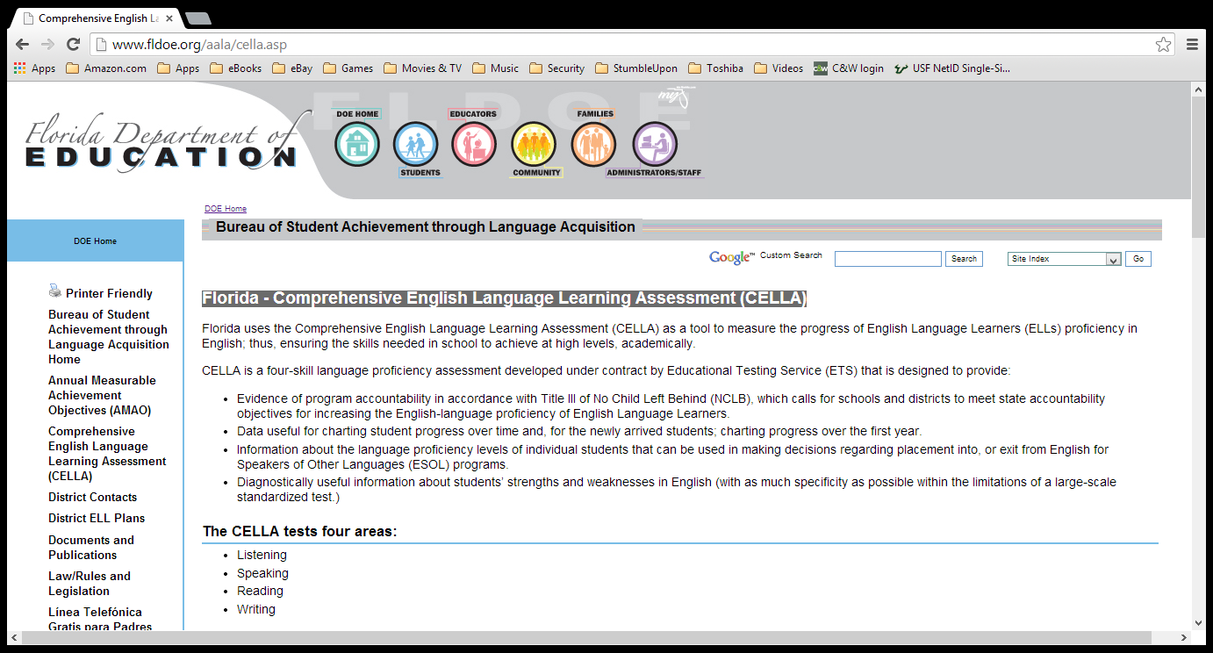
The Comprehensive English Language Learning Assessment helps to measure the progress of ELL’s in their ability to use the English Language. This test assesses Listening, Speaking, Reading, and Writing and can give us valuable information on how much they are able to use the language and what accommodations we can provide to meet their specific needs.
CELLA

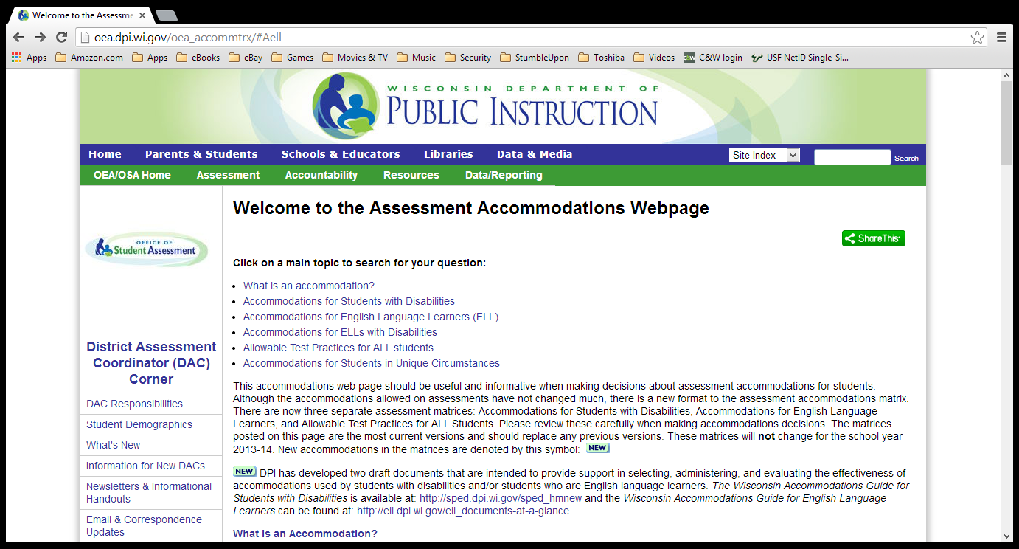
This website is an excellent resource for knowing what accommodations are for assessment, when it is appropriate to use them, and which accommodations are appropriate for which students.
http://oea.dpi.wi.gov/oea_accommtrx/#Aell
Parent/Community Involvement

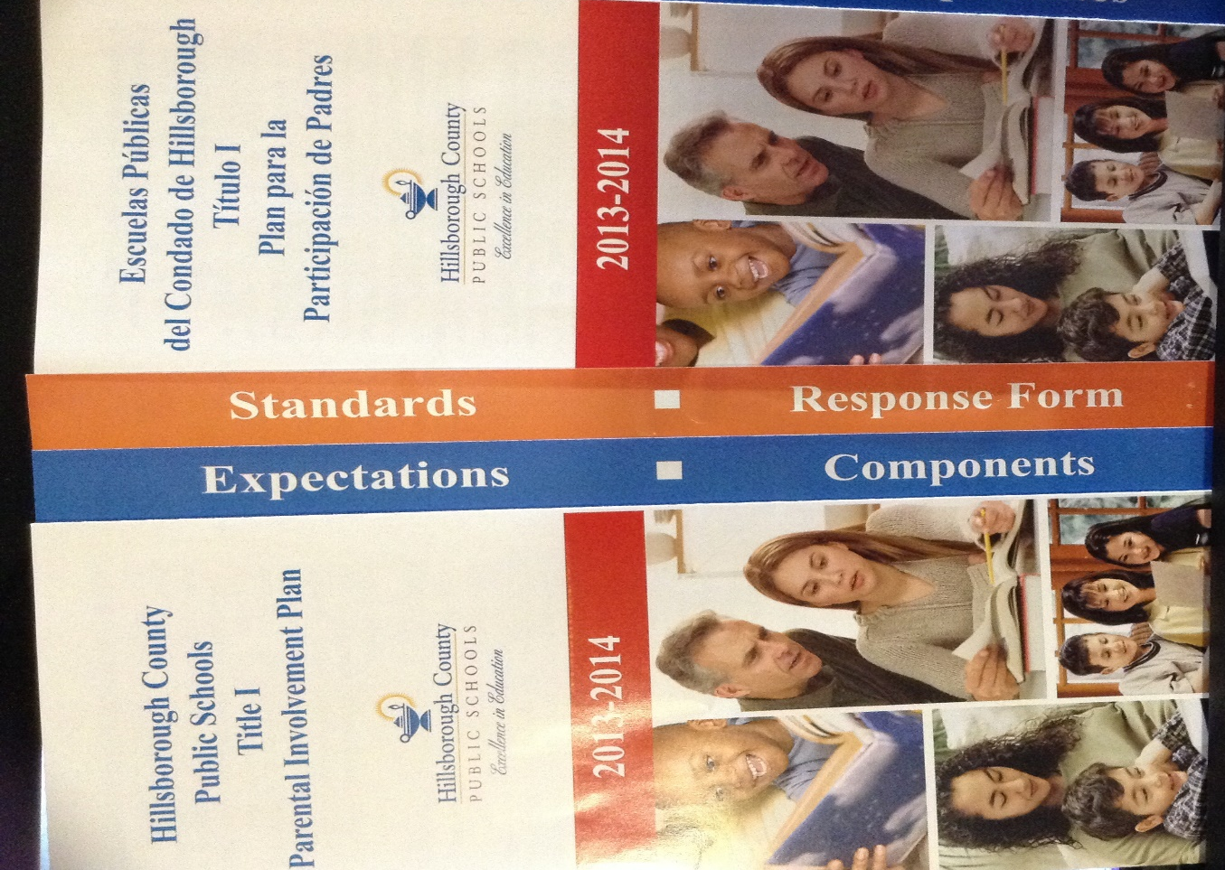
This packet is wonderful to send home for the parents or guardians of ELL’s. The packet gives an explanation of expectation for parental involvement as well as expectations for the school in including parents and families. There is a description of the standards of parent involvement as well as a response form for parents to complete and return if they have any questions or concerns, or just need additional resources. This packet is printed in English and Spanish. In this area, Spanish is the most common native language of our ELL’s, however, this brochure can be printed in other languages as needed.
Parent Involvement Packet
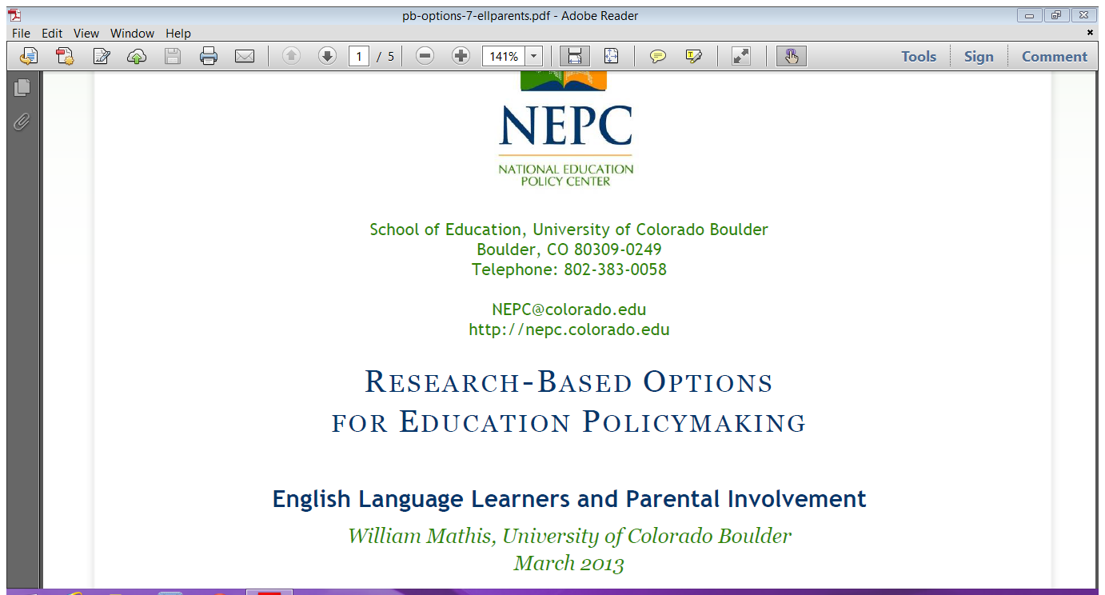
This PDF is accessible online. It includes examples of parent involvement that includes different cultures and languages as well as recommendations for how to accommodate families that are not native English speakers at the government level as well as district and school level. This PDF contains an abundance of information regarding the needs of families and some of the reasons for lack of parental involvement that can be fixed by making accommodations for these families.
nepc.colorado.edu/files/pb-options-7-ellparents.pdf‎

Content Area/Grade Level

http://www.english-4kids.com/grade3.html

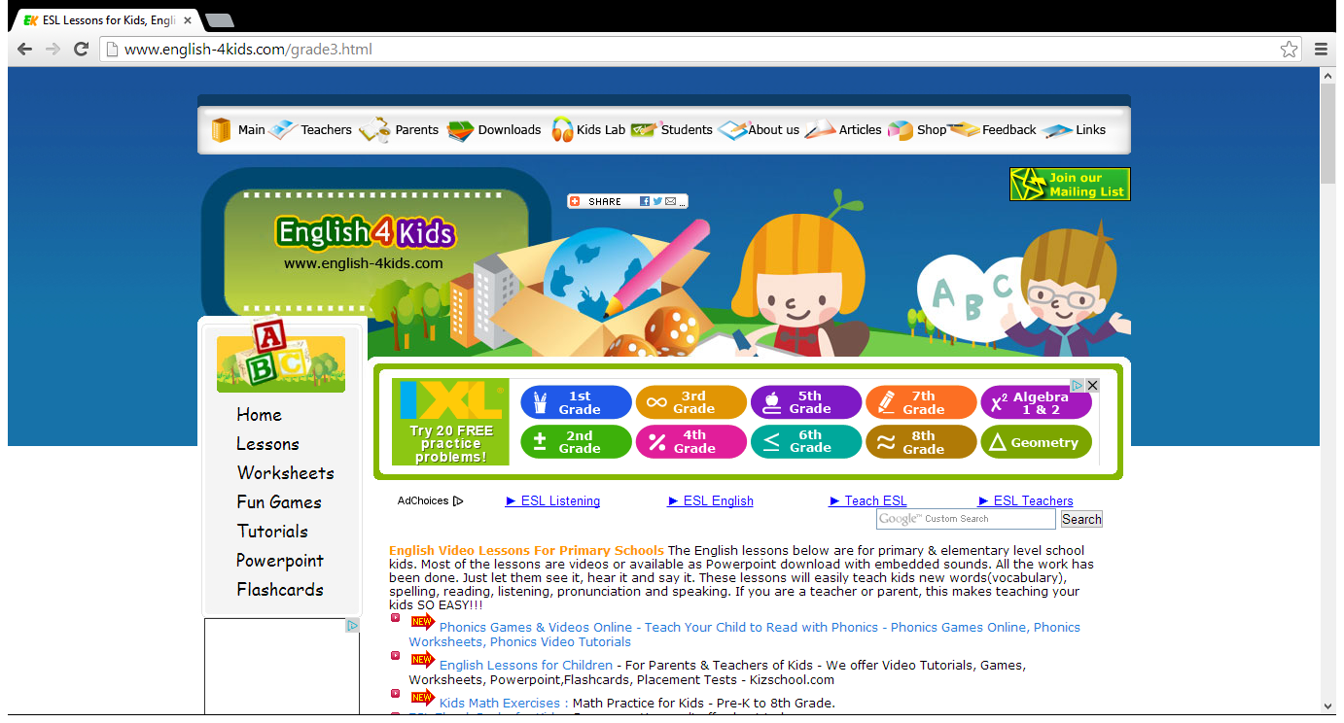
This website has video lessons for primary grades that incorporate sounds, pictures, and multilingual instruction to help students learn content area language.
English 4 kids

This worksheet contains academic vocabulary words that can have more than one meaning. This is helpful to introduce English vocabulary that has dual meanings to ELL’s, and to show them in what instances they can be used in writing. The worksheet comes with a word bank and sentence frames. This photo is only of the first page of the lesson; the entire lesson is about 6 pages of material.
Academic Vocab Lesson

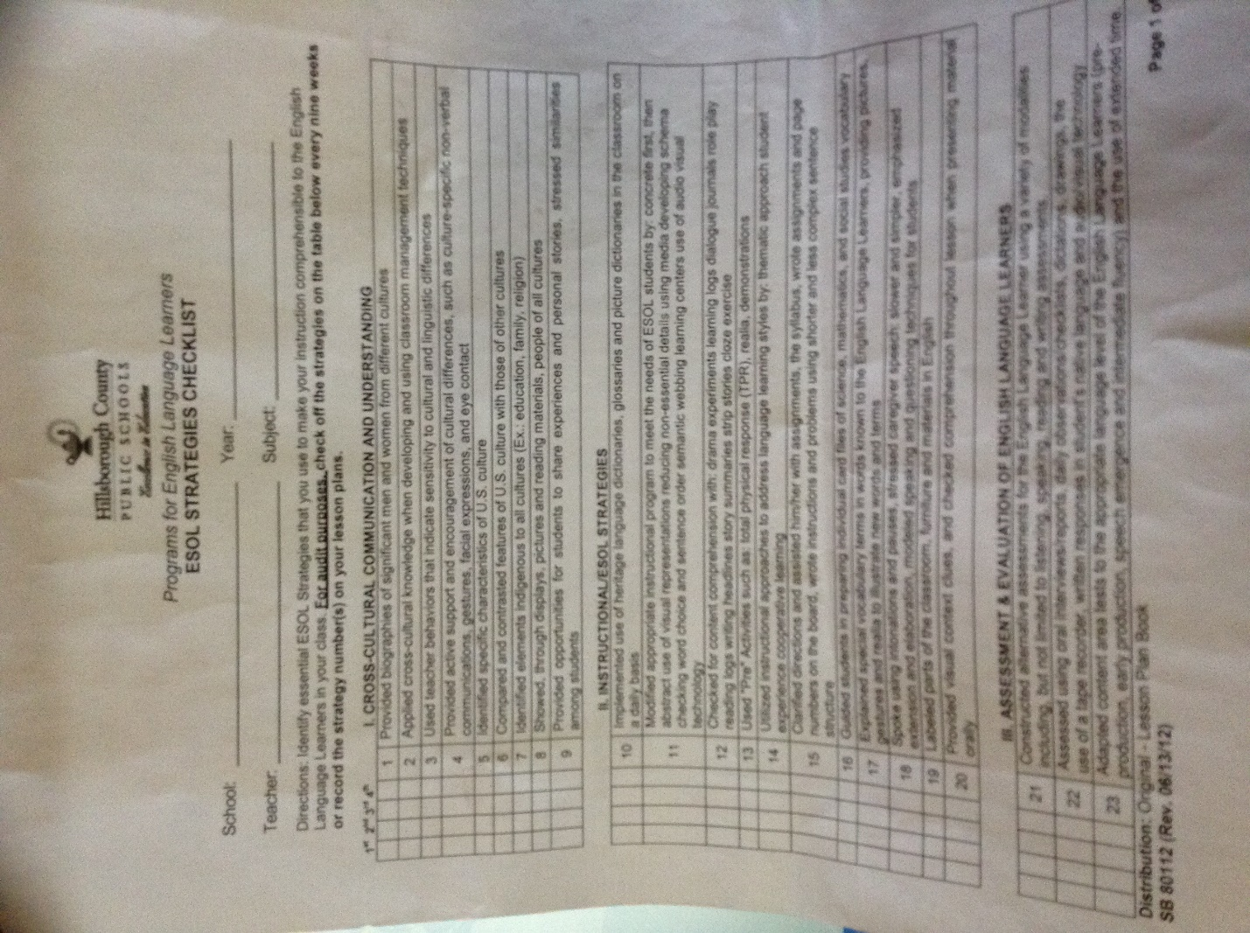
This is a great resource to make sure that you are providing adequate accommodation throughout your instruction.
ESOL Strategies Checklist
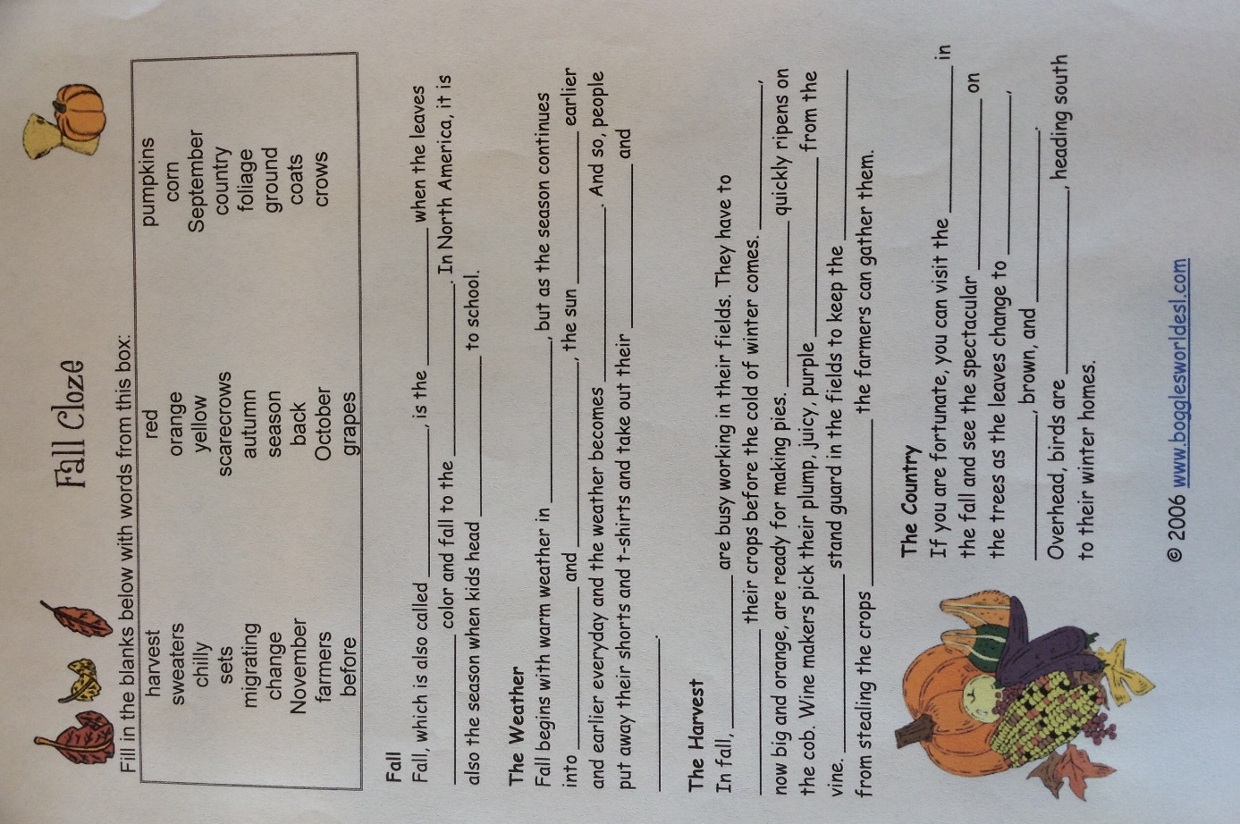

Cloze activities can be modified to include any content specific language or vocabulary. This helps ELL’s to acquire meaning for these words by placing them in the provided sentence frames, without having to struggle with sentence structure and grammar.
Cloze Activity

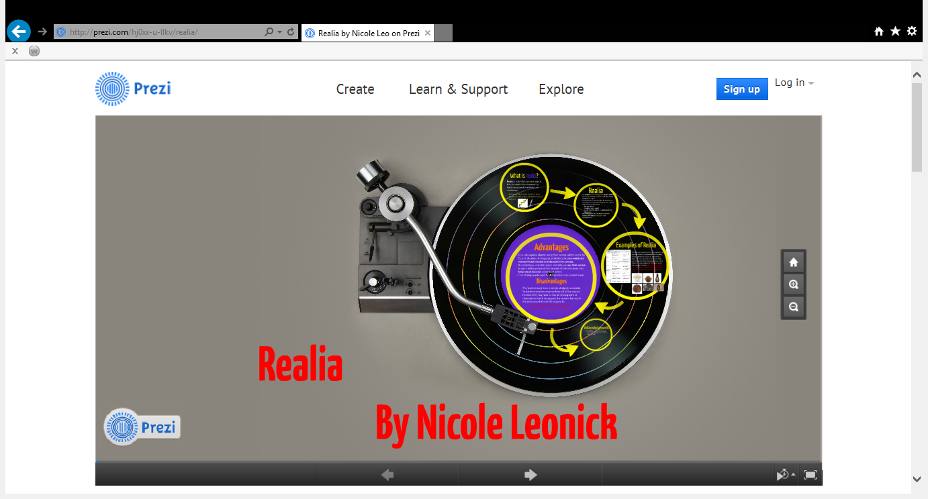
Most useful in subjects like science and math, where real physical objects or pictures can be provided to help with translation of items. Providing a physical, touchable, object helps ELL’s make connections between the object and the word that represents the object.

The screenshot on the left is a direct link to a Prezi about Realia.
Realia
Alphaboxes or Alphabet boxes can benefit ELL’s by helping them record familiar or unfamiliar vocabulary in a text. They can build there alphabox, then can research word definitions and continue to use the alphabox as a personal word wall. This may also be used for assessment to see what vocabulary in a text that they are familiar with.
Alphabox

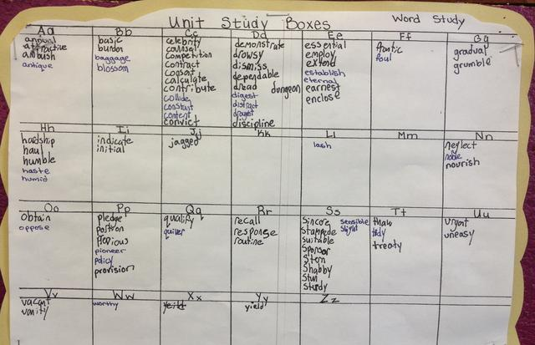

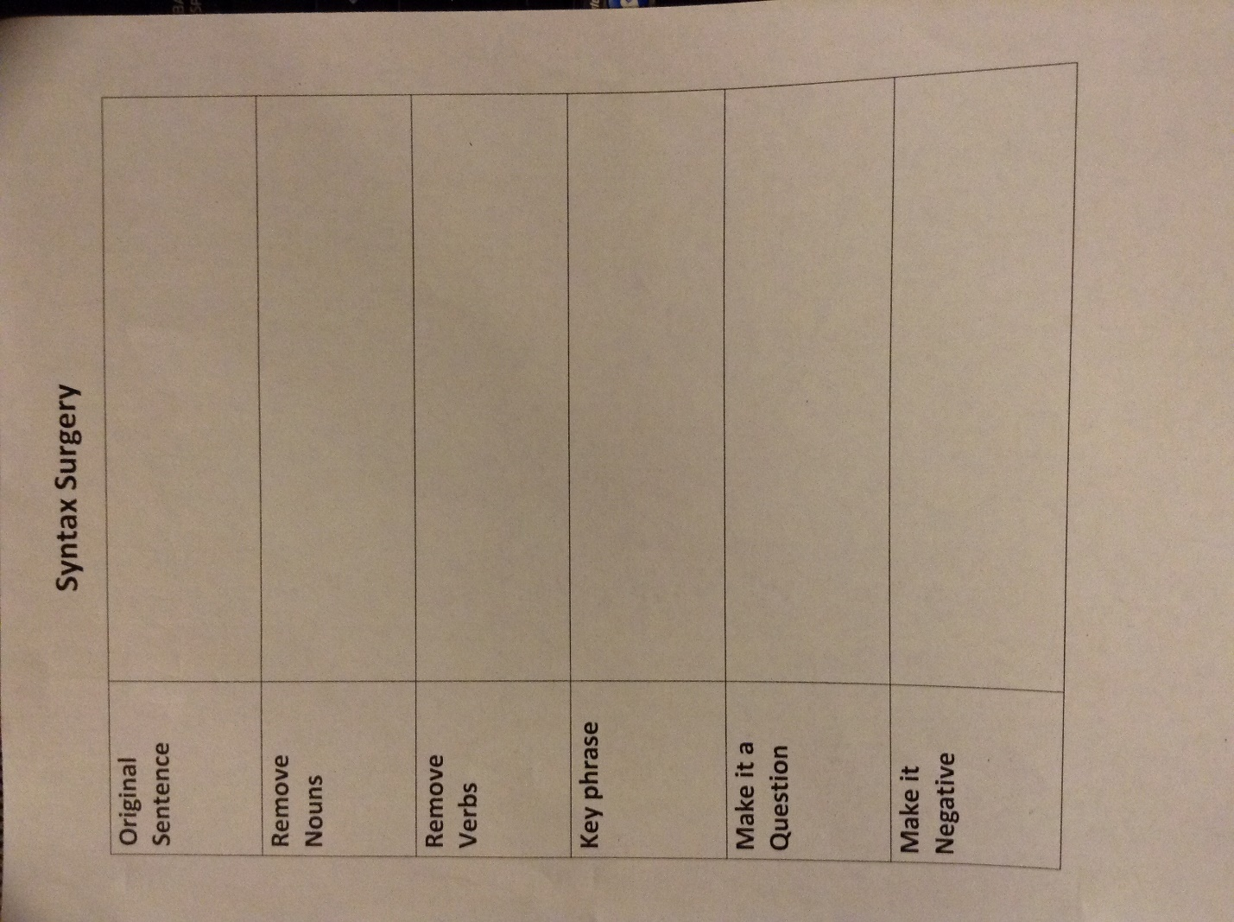
This strategy can be used during any writing lesson to help a student take apart a sentence and modify it. This allows students to get hands on work with language and its uses. You can use this in place of a writing lesson by providing a sentence for the student to perform the surgery on while the rest of the class completes the same or any other writing assignment.
Syntax Surgery

Program Models

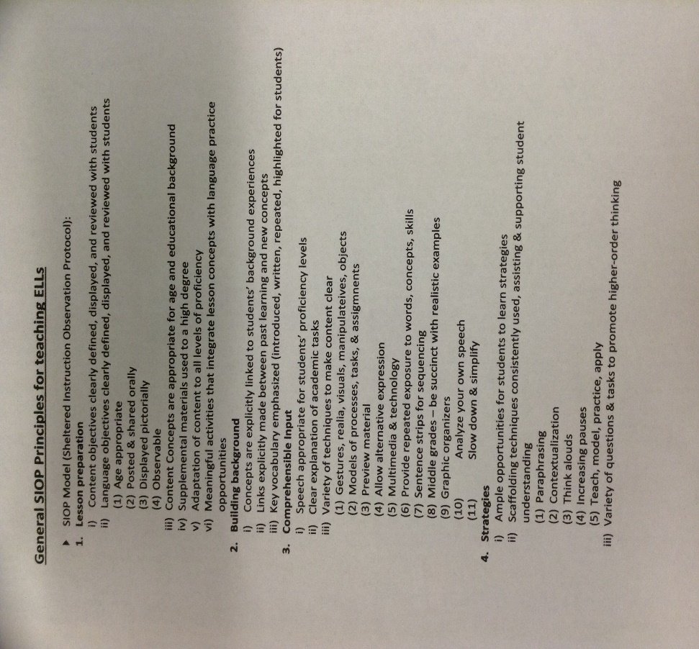
This model gives us guidelines to follow to make sure that we incorporate all the necessary components into our lesson that meet the needs of ELL’s. Using this model, and linking prior knowledge to current lessons, help to ensure comprehension of content.
SIOP Model Guidelines

